Created by Camille Weber, the 28 February 2013
Modified by Lionel Weber, the 28/02/2013

Wigii Addons concepts

Addons are stored in the path :

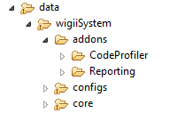

Each addon has its own folder. At the root level of the addon folder should be the addon classes. The addon can have some subfolders to store other files like database sql scripts for installation, documentation, examples, etc :

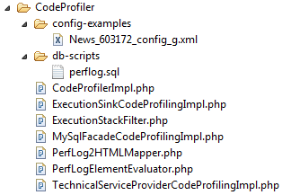

The addon should provide its own TechnicalService or ServiceProvider in order to be activated or explain in a documentation own to activate it.
The addon can use and subclass any classes of the API or the web interface classes.

Common activation points for addons are :
- ElementEvaluator implementation declared in a group config or module config
- ExecutionSink replacement
- ExceptionSink replacement
- DebugLogger replacement
- Wrapper of any service in the ServiceProvider or TechnicalServiceProvider
- Create a wigii event subscriber and register it into the EventSubscriberService

Declare the addon in the /data/wigiiSystem/core/_webImplExecutor/autoload.php file :

////////////////////
// wigii Addons
// default path is: define("ADDONS_PATH", wigiiSystem_PATH . "addons/") in index.php
//
// addon: CodeProfiler
if(!defined("ADDONS_PATH")){
if(is_dir(wigiiSystem_PATH . "addons/")){
define("ADDONS_PATH", wigiiSystem_PATH . "addons/");
}
}
if(defined("ADDONS_PATH")){
if (!$ok)
$filename = ADDONS_PATH."CodeProfiler/$class_name.php";
if (!$ok)
$ok = file_exists($filename);
// addon: Reporting
if (!$ok)
$filename = ADDONS_PATH."Reporting/$class_name.php";
if (!$ok)
$ok = file_exists($filename);
}
// end wigii Addons
////////////////////

For central constant definition or if you want to use another location, define the constant ADDONS_PATH in the index.php :

define("ADDONS_PATH", wigiiSystem_PATH . "addons/");

